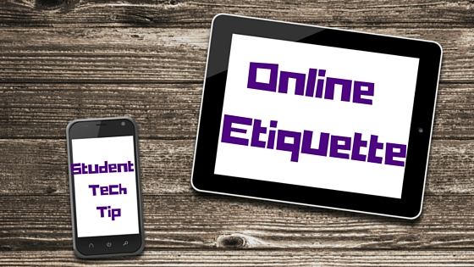

**As an online student at Gateway Middle, communication is a bit different than in a face-to-face setting.  We pride ourselves in providing several opportunities for social interactions, but the difference is that most communication is via written text in an online environment.  Because this means you are missing body language cues and immediate feedback from your “listener,” it is very important to understand some common rules for good online etiquette.  This ensures that the message you intend to convey is received correctly.**

1. **Be respectful.** While it is easier to say hurtful or disrespectful things without standing face-to-face with someone, it is important to remember that your classmates and teachers are real people who are affected by the words you say and write.  It is essential to keep in mind the feelings and opinions of others, even if they differ from your own.  ***If you wouldn’t say it to someone’s face, don’t say it online either.***

2. **Be aware of strong language, all caps, and exclamation points.** It is easy for written text to be misread and misunderstood.  Have you ever sent a text message with good intent but your recipient thought you were being rude? If so, then you’ve experienced this firsthand.  By being cognizant of strong language, you can identify potential confusions before sending messages.  ***Tip: Read everything out loud before you send it.***

3.**Be careful with humor and sarcasm.** Certainly you shouldn’t avoid being funny. We love to see your personality shine through in online classes.  Many of our teachers are exceptionally funny too.  But like mentioned in Rule #2, make sure that it is clear you are being funny and not being rude. Emoticons and smileys can be helpful when conveying humor or sarcasm so that it is read correctly. Just remember to keep the smiley faces away from academic papers. 😉

4. **Yes, grammar and spelling matter.** While texting, textspeak can b gr8 4 ur friends.  In an educational setting (even online) however, keep it formal.  Your written communication should be professional and reflect proper writing style.  Save written shortcuts and less than stellar grammar for Snapchat if you must, but follow grammar rules for school.

5. **Cite your sources.** Whenever you are sharing an idea that originated from someone else (even if it is not word for word), it is good practice to cite that source.  This applies to discussion forums too.  If you read a great thought in your text, share it, but be sure you let your audience know where you saw it first.

6. **Don’t post or share (even privately) inappropriate material.** Enough said there. Nothing is truly private online.

7. **Be forgiving.** Remember that not everyone will know these rules before posting. Try to be understanding of others when they struggle with written communication.  It is very different than simply talking to a person face-to-face.

 These rules were adapted from the following sources:

Albion, (2015). *The Core Rules of Netiquette — Excerpted from Netiquette by Virginia Shea — Albion.com*. Retrieved 26 August 2015, from http://www.albion.com/netiquette/corerules.html

Common Sense Media, (2015). *7 Rules to Teach Kids Online Etiquette*. Retrieved 26 August 2015, from https://www.commonsensemedia.org/blog/7-rules-to-teach-kids-online-etiquette

Connor, P., (2015). *Netiquette: Ground Rules for Online Discussions*. Retrieved 26 August 2015, from http://teaching.colostate.edu/tips/tip.cfm?tipid=128

Madison College, (2015). *Online Etiquette Guide | Madison Area Technical College*. Retrieved 26 August 2015, from http://madisoncollege.edu/online-etiquette-guide

Rinaldi, A. (2015). *The Net: User Guidelines and Netiquette, by Arlene Rinaldi*. Retrieved 26 August 2015, from http://courses.cs.vt.edu/~cs3604/lib/Netiquette/Rinaldi/